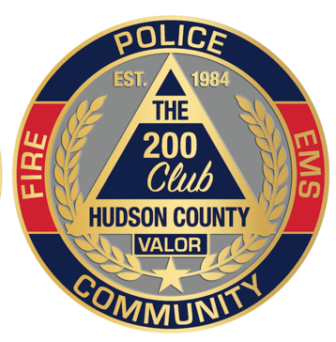

The 200 Club of Hudson County

is a 501(c)(3) Non Profit Organization

23 Chapel Avenue, Jersey City, NJ 07305

(201) 618-3200

*mhulings@connellfoley.com*

**The 200 Club**

**of**

**HUDSON COUNTY, NEW JERSEY**

August 2024

Dear Friends,

Every spring the 200 Club hosts a Valor and Scholarship luncheon where the community acknowledges support for the essential services provided every day and night by Police, Firefighters and EMS who enforce our laws and protect our lives and property. Valor and Valiant Teamwork Awards are presented to those who perform their duties with extraordinary valor. Children of eligible public safety officers are awarded Scholarships at the Luncheon. Without your support none of this would be possible.

When an officer is killed in the line of duty or seriously injured in the line of duty the 200 Club presents an immediate, no-strings attached check to the family to help them cope with critical expenses in their time of need.

September 27th has been designated as **“First Responders Day”.** For the past five years the 200 Club has hosted its Annual “First Responders Day Golf Outing”. Our Golf Outings have been tremendously successful due to your support which enables the 200 Club to continue its mission.

This year’s  ***Annual “First Responders Day” Golf Outing*** will be held on **Friday September 20, 2024** at Hudson County’s Skyway Golf Course located in Jersey City.

We are hoping that you join us on September 20th for an afternoon of golf and camaraderie.

Enclosed please find a brochure with the different ways you can support our event.

On behalf of the Officers, Trustees and Members of the Hudson County 200 Club, thank you for your continued support.

Sincerely,

Maureen Hulings Timothy Griffin

Executive Director President

Encl.

**OFFICERS:**

**Chief Timothy Griffin**

***President***

**Brian McDonough**

***1st Vice President***

**Hon. Anthony Romano**

***2nd Vice President***

**Dep. Chief Daniel Solitti**

***Secy/Treasurer***

**Maureen Hulings**

***Executive Director***

**TRUSTEES:**

John Burns

Frank Cretella

Hon. Edward DeFazio

Joseph Giannella

Leo J. Hurley, Jr., Esq.

Michael McCabe

Kevin O’Connor

Joseph A. Panepinto, Sr.

Hon. Joan M. Quigley

Robert Quigley

Rev. Francis E. Schiller

James Sharrock

Mark A. Smith

Jeff Welz

**PAST PRESIDENTS:**

Norman E. LaGueux

William (Tex) Jackson

Hon. Joan M. Quigley *

Steven R. Ross

H. Mickey McCabe

Daniel F. Becht, Esq. *

Mary Beth Stull

David J. Cohn

Jeff Welz

Hon. Joseph Cassidy

Jerome A. Cala

Michael Novak

Daniel DeTrolio

Joseph Giannella

James Sharrock

*\* 2 Terms*